**Final Assignment**

Develop an application to fetch Quick Books Online (QBO) report (P&L or Balance Sheet or Statement of Cashflow) and display it on the interface. QuickBooks is an accounting software which is getting used by most of the US Companies or firms. QuickBooks allow to fetch accounting reports either using the interface or rest APIs. this application we will use the QBO APIs for fetching accounting report’s data.

**This application can be divided into following parts or steps: -**

* Extract report data from QBO using QBO API and display the data on the interface in specific format (kindly refer to the below image).

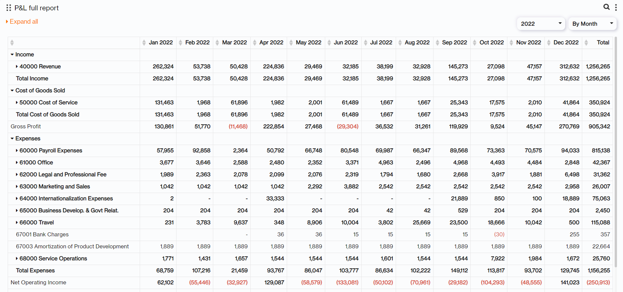

* There should be a button in the UI to importing the data to the database.
* On Clicking the button, the data will be stored in a database.

Note:

1. Your application frontend should be in **ReactJS** and Backend should be in **NodeJS** and for the APIs **Python** willbe used.
2. Do comment in the code as per industry standards.
3. While creating database structure(s) follow **Normalization**

**API’s List:** We have mentioned following three API endpoints of 3 QBO reports. You can choose any one of these and use it for fetching the report data.

* **Profit And Loss:** <https://developer.intuit.com/app/developer/qbo/docs/api/accounting/report-entities/profitandloss>
* **Balance Sheet:** <https://developer.intuit.com/app/developer/qbo/docs/api/accounting/report-entities/balancesheet>
* **Cash Flow:** <https://developer.intuit.com/app/developer/qbo/docs/api/accounting/report-entities/cashflow>

**Creating QBO Account**

Follow the steps given below for creating QBO account and generating access token

**Signup**: [Click Here](https://accounts.intuit.com/signup.html?offering_id=Intuit.devx.devx&iux_target_aal=25&iux_sso_mfa=true&redirect_url=https%3A%2F%2Fdeveloper.intuit.com%2Fapp%2Fdeveloper%2Fhomepage%3FdevXlogin%3Dtrue) to create an account.

1. Create App on QBO

https://developer.intuit.com/app/developer/dashboard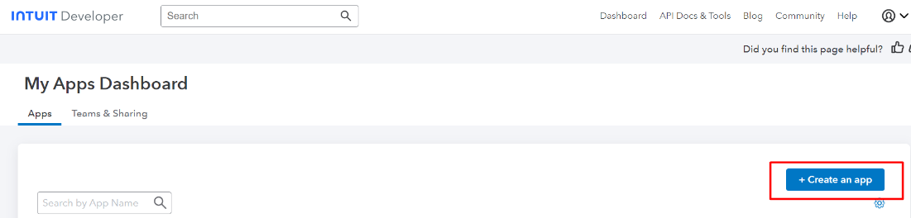

1. Add the App name and Select Scope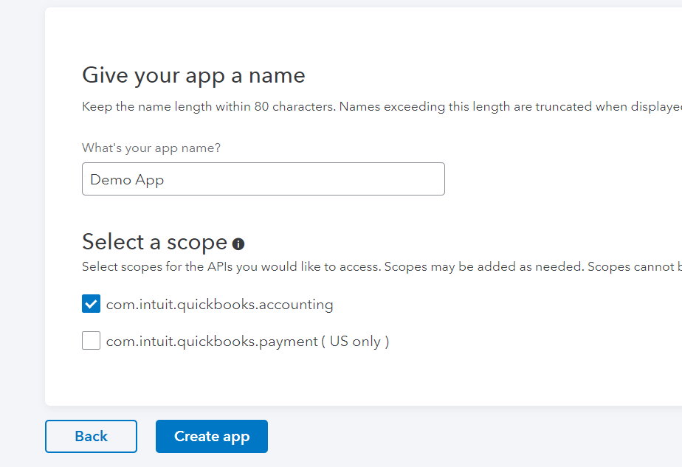
2. Copy OAuth key and follow the further process 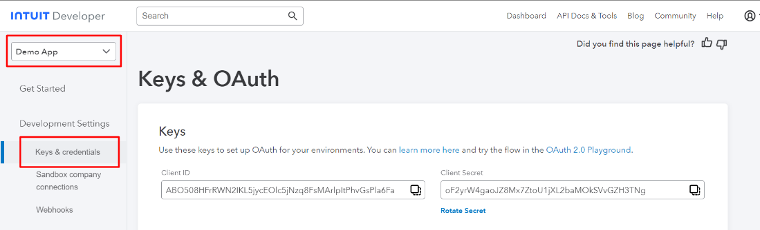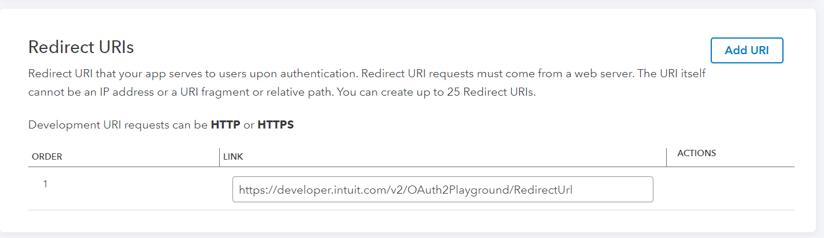
3. Company Page will look like below image and you can check reports from here.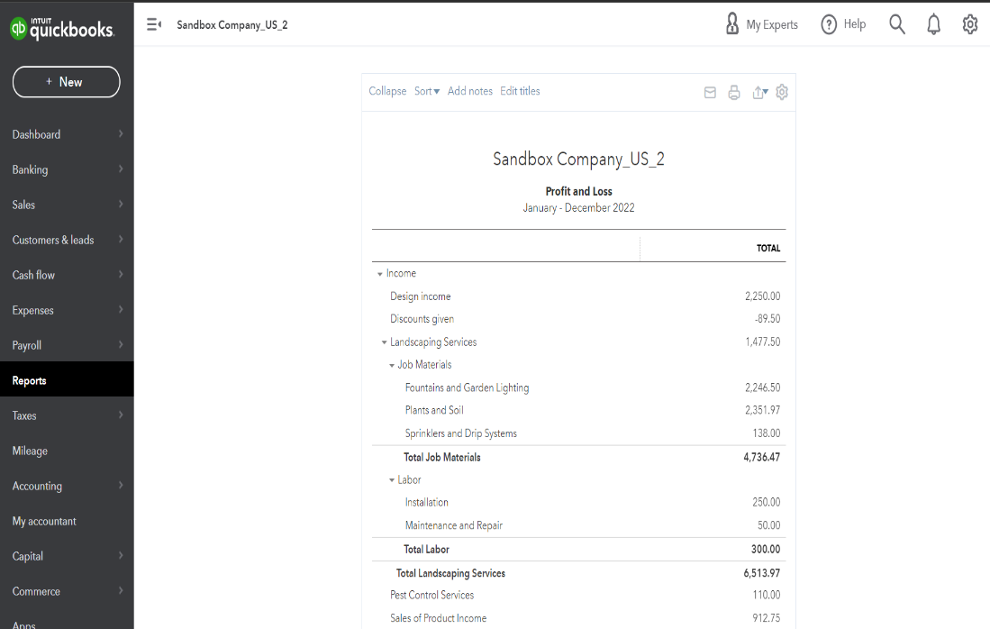

**Sandbox**: Create a sandbox account with the QBO developer account credential.

1. [https://developer.intuit.com/app/developer/sandbox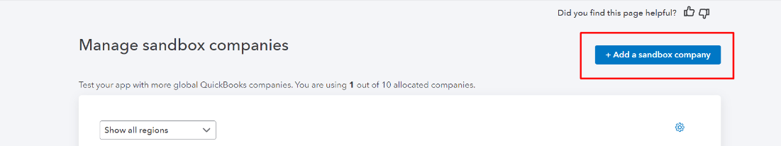](https://developer.intuit.com/app/developer/sandbox)
2. Add Client ID and Client Secret key in OAuth 2.0 Playground and get the Access token, use it in API

Playground: [https://developer.intuit.com/app/developer/playground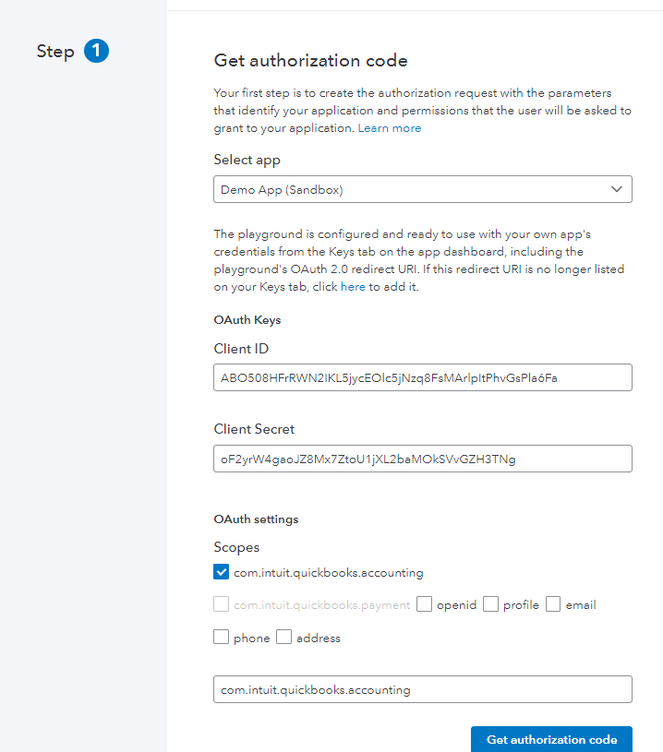](https://developer.intuit.com/app/developer/playground)